**Project Title**:CookBook:your virtual Kitchen Assistant

**Team ID:**

**Team Leader:**S.Shangamithra

**Mail ID**:mithrakathir1014@gmail.com

**Team Members**:

* Gunasree:vijaygunasri27@gmail.com
* Ashwin:ashwinvenkat132005@gmail.com
* Anvar Ali:anvarmubarak100@gmail.com

**Project Overview:**

* **Purpose:**
  + The cookbook application is designed to simply meal preparation by offering a virtual kitchen assistant
  + Users can browse,save,and manage their favourite recipes with detailed instructions and ingredients lists
* **Features:**
* Extensive Recipe Library with search &filter operation
* Step by step Cooking Instructions
* Bookmark Feature For favourite Recipes
* Light/dark Mode for Enhanced Visual Comfort
* Responsive Design for opetimal Viewing on all Devices
* Ingredient CheckList for easy Shoppiing and preparing

**Architecture:**

* **Component Structure:**
* **App.js-**Root component managing layout and routes
* **Headre.js**-Navigation bar with search functionality
* **RecipetList.js**-Displays categorized recipe cards
* **RecipetCards.js**-Individual card displays recipe details
* **RecipeDetails.js**-Detailed view of selected recipe
* **Footer.js**-Provides additional resources amd links
* **State Managemet**:Context API
* **Routing**:React Router

**Setup Instructions**:

* **Prerequisties**:
* Node.js
* Mongodb
* **Installtion:**
* Clone the Repository: PS C:\Users\BSC 18\Downloads\code-20250915T062623Z-1-001\code>
* Install Dependicies: npm install
* Run the application :npm start

**Folder Structure**:

/src

|_components

|_Header.js

|_RecipeList.js

|_RecipeCard.js

|_RecipeDetails.js

|_Footer.js

|_\pages

|_Home.js

|_Categories.js

|_Bookmarks.js

|_\assets

|_images

|_icons

|_styles

|_/utils

|_\api.js

|_helpers.js

|_constants.js

|_App.js

|_index.js

**Running the Application:**

* Frontend- cd client npm start
* Backend-Cd server npm start
* Access:Visit <http://localhost:3000>

**API Documentation**:

* **User**:

-/api/user/register

-/api/user/login

* **Projects:**

-/api/projects/create

-/api/projects/:id

* **Application:**

**-/api/apply**

**Authentication:**

**User Interface:**

* Clean and intuitive layout optimized for smooth navigation
* Mobile-first design for seamless browsing
* Elegant light/dark mode toggle for improved accessibilty

**Testing:**

* Jest for unit testing
* React Testing Library for component testing
* Code Coverage:Ensured high test coverage with jest reports

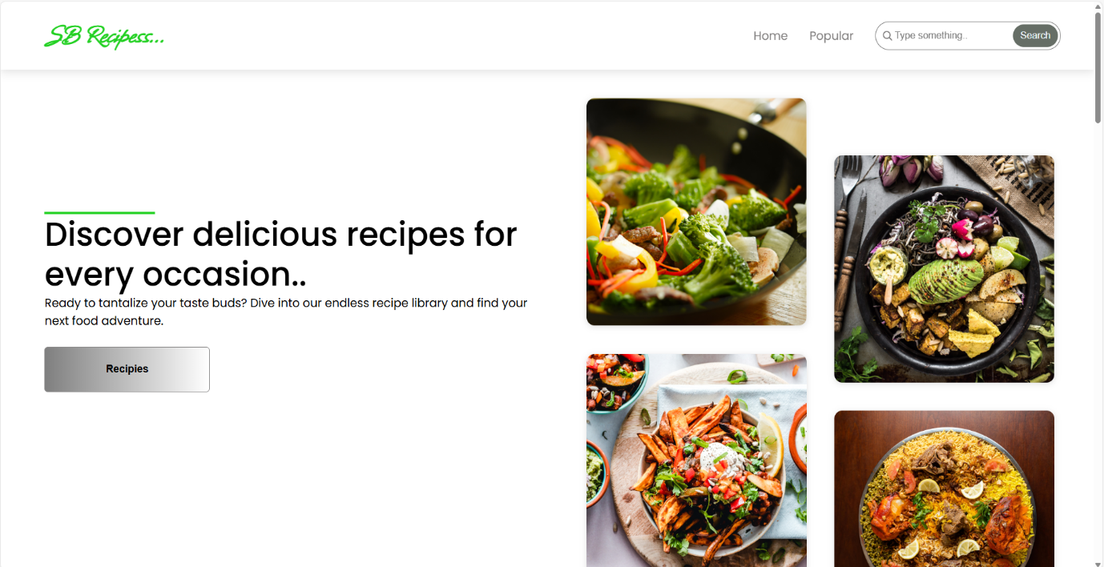**=Screenshots or Demo:**

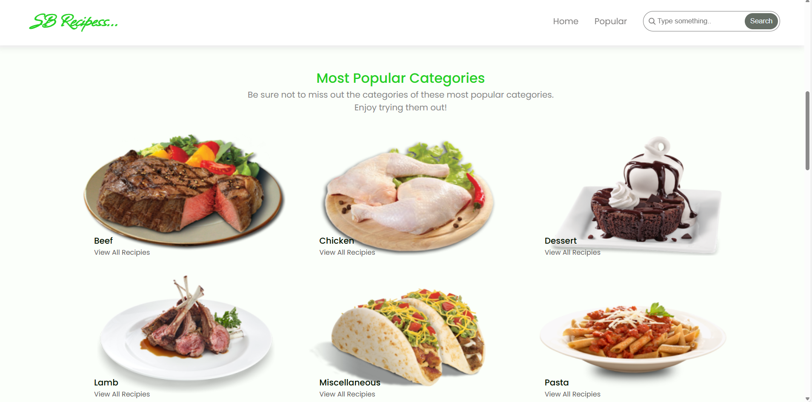

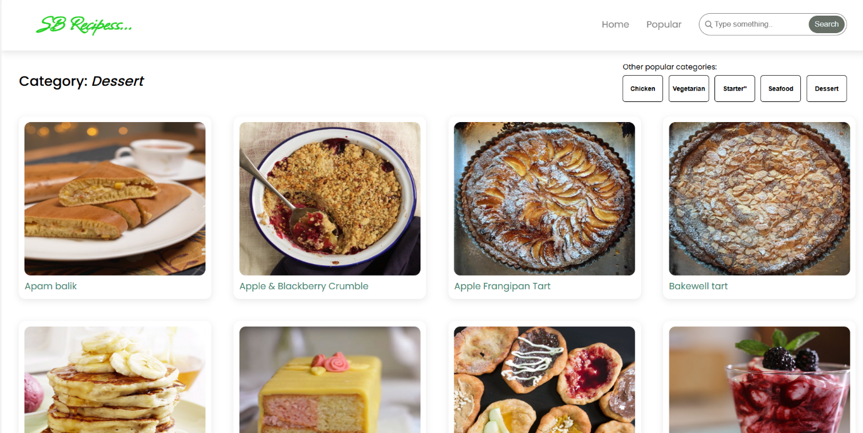

**Live demo link:**

**Known Issues:**

* Certain API endpoints may experience delays during peak traffic
* Ingredient checklist feature may require further optimization

**Future Enchancement**:

* AI-Based Recipe Suggestions
* User Authenciation for personalized recipe collection
* Integration with Grocery Shopping Platforms
* Offline Mode for accessing saved recipes